Onyx Web Services
Onyx M.E.T.S.
Architecture

Prepared by: Dan Ledrick
Version: 1.0
Last update: 9/14/2004 9:23 PM



Table of Contents

1. Overview 1
1.1. Purpose 1
1.2. Business Requirements 1
1.3. Product Description 1
2. The Logical Architecture 2
2.1. OEP/OEDB 2
2.2. METS Client 2
2.3. External Web Server 3
3. Onyx METS Physical Architecture 4
3.1. Internal Network 4
3.2. External Network 4

Revision History

Version | Date | Description | Author
1.0 | 9/14/2004 | Initial Draft | Dan Ledrick

Review History

Version | Date | Reviewed By
1.0

Overview

Purpose
This document details the technical architecture for the Onyx Mass Email and Tracking System (METS).

Business Requirements
Email marketing is vital to getting immediate, relevant materials to prospects and customers. The visual layout and information that an email communication contains is vital to the impact it has. HTML emails have become a standard in communicating to large groups of recipients. As more email clients accept HTML emails, the use of this technology will continue to grow.
Our goal was to deliver technology that sends media-rich, HTML emails to a list of recipients generated by Onyx Employee Portal (OEP). The technology would encrypt user information and track a recipients opening and actions related to the email directly in OEP. The tracking mechanism must not appear to be ad-counting to popular Spam-filters to ensure that more recipients are reached. Finally, an unsubscribe functionality must be integrated with OEP that allows for unsubscribing from a particular marketing campaign as well as unsubscribing from all future communication.

Product Description
The METS application is a simple set of web pages that receives information from the Onyx Employee Portal and provides additional fields for information about the email: such as tracking and unsubscribe information; sending address; and HTML content. When the METS client begins executing, it encrypts the information into the HTML provided and sends to each recipient using an SMTP server. Logs are kept during the send process. When the recipient views the email, images are requested from an externally resolved server. One of these images is a request to a special web application that executes a stored procedure to OEP and binary writes an image back to the requesting HTML email.
The METS application has three distinct areas:
- OEDB/OEP includes stored procedures that encrypt and return email recipient information, decrypt recipient information and utilize core-product stored procedures to set actions in Onyx Employee Portal.
- METS Web Client residing with an SMTP server to set additional information about the communication, encrypts user data, and actively sends the email to the recipient.
- An HTTP Handler residing on an externally resolved web server that executes an action in OEP to track the recipients that view the email.

The Logical Architecture
In this section, we will describe the various logical components that are required and/or desired when implementing METS. The following diagram depicts the logical components followed by a description of each.
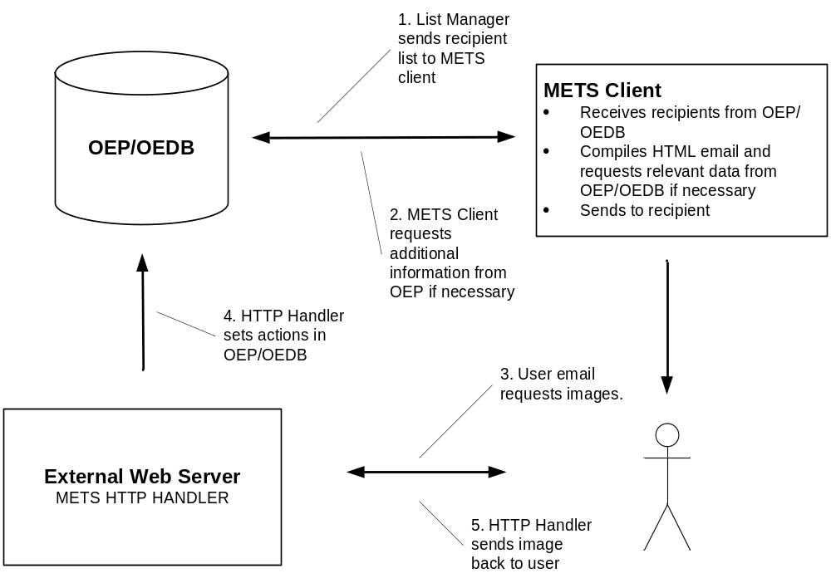

OEP/OEDB
List Manager selects the audience for the mass email. By setting a ‘Bulk Action’, a list of users is sent to the METS client.

METS Client
The METS client receives the list of users and offers up fields for additional set up of the email. This includes: the subject, sender, action to be taken when email is viewed, opt-out options and HTML content for the email. The METS Client will then need to make additional requests to OEP/OEDB when necessary to retrieve data relevant to the body of the HTML.

External Web Server
When the user receives the HTML email, images for the HTML are requested from a public/external web server. All images are served normally except for a special “Tracking Image” that is retrievable from an HTTP Handler. The code to request this image is automatically inserted by the METS Client.
The HTTP Handler receives the request for the image, and uses the image name to decrypt the user information and set the appropriate actions in OEP/OEDB. The HTTP Handler will then binary write a blank image file to the HTML email.
Similarly, if the user wishes to opt-out of the email campaign, and clicks the link to ‘Unsubscribe’, an ASP page is requested from the external web server that sets the appropriate actions in OEP/OEDB. The code that places the opt-out functionality into the email is automatically inserted by the METS Client.

Onyx METS Physical Architecture
There are various ways to set up the physical architecture of the above process. Below is the recommended way to set up the relationship between OEP, the SMTP Server and the external web server.
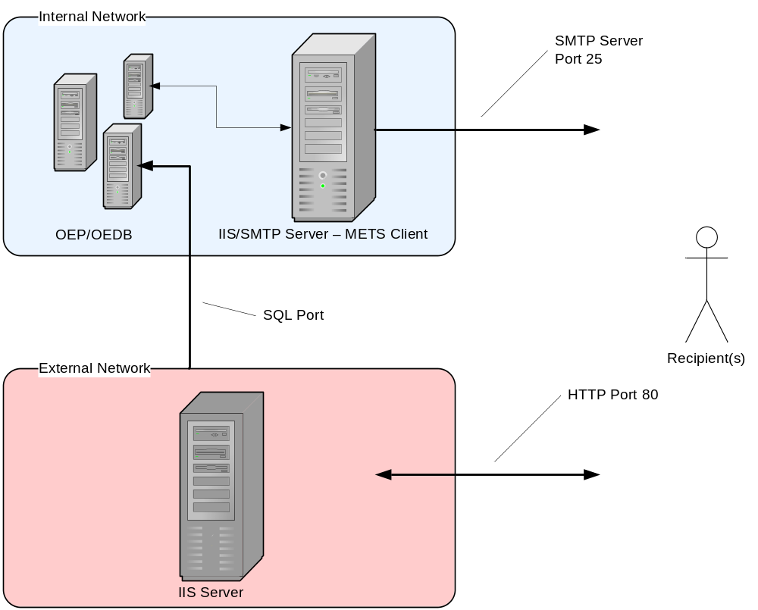

Internal Network
The internal network would hold the OEP/OEDB application servers as well as an SMTP/IIS machine for the METS Client.
The List Management functionality of OEP will launch the METS client to populate the application with recipients.
Stored Procedures running in the OEP/OEDB environment will send additional information to the METS client as needed. CDO objects residing on the SMTP/IIS machine are used to send the email via standard SMTP port 25.

External Network
The external network is required for the web server to serve images requested by the HTML email. This web server also contains the HTTP Handler which will set the action in OEP/OEDB when the user reads the email. A SQL port between the two systems needs opened in order to set the appropriate action in OEP. This port can be protected via Firewall software.

